Travis Moore

FLM151: Section B — Fall 2016

Instructor: Kent Beeson

**­**

Film Analysis #4  
Camera Map

1. Write a 100 word analysis and cite at least 3 references about the assigned scene from *What’s Up Doc?* and answer the following questions:

a) How does this scene relate to the story?

The drug store scene in *What’s Up Doc?* relates to the nature of the screwball comedy story that director Bogdanovich is trying to tell. The drugstore scene features several moments of slapstick, mistaken identities, and inane concerns for motives that recall the comedic references of the thirties (Canby). This scene furthers the nature of the film by giving us the plot of the story in the form of a screwball comedy.

b) How does this scene affect the outcome of the film?

The drug store scene in *What’s Up Doc?* provides the viewer with both a character setup and a piece of information that nicely wraps up the movie. Howard is established as being a sort of absent minded professor while Judy’s character shows she has an impressive amount of knowledge despite not having any credentials. Judy’s character reveal is especially important because this information is crucial to how she is able to call out Hugh as a plagiarist at the end of the film, essentially awarding Howard the Larrabee Foundation grant he’s been trying to get (TV Tropes). Without the setup provided by the drug store scene the viewer wouldn’t have any previous knowledge of how Judy is able to recall facts from out of nowhere.

c) Which part of the film structure is represented in this scene?

The drug store scene in *What’s Up Doc?* sets the plot and the catalyst for the film. Despite trying to avoid Judy, Judy is persistent in finding out who Howard is and why he is in town. By bumping into Howard at the drug store and learning what he’s all about, Judy sets her sights clearly on pursuing Howard, despite his request for her to “go away and just leave me alone” (Huntley). This scene gives the viewer all the information they need to understand the situation for Howard and Judy and sets up the great chase of Judy trying to win over Howard.

2. Create a camera map of the scene. Identify the two main characters by name and label the props and set items. Use solid arrows to show the direction of movement of cameras and dotted lines for characters.

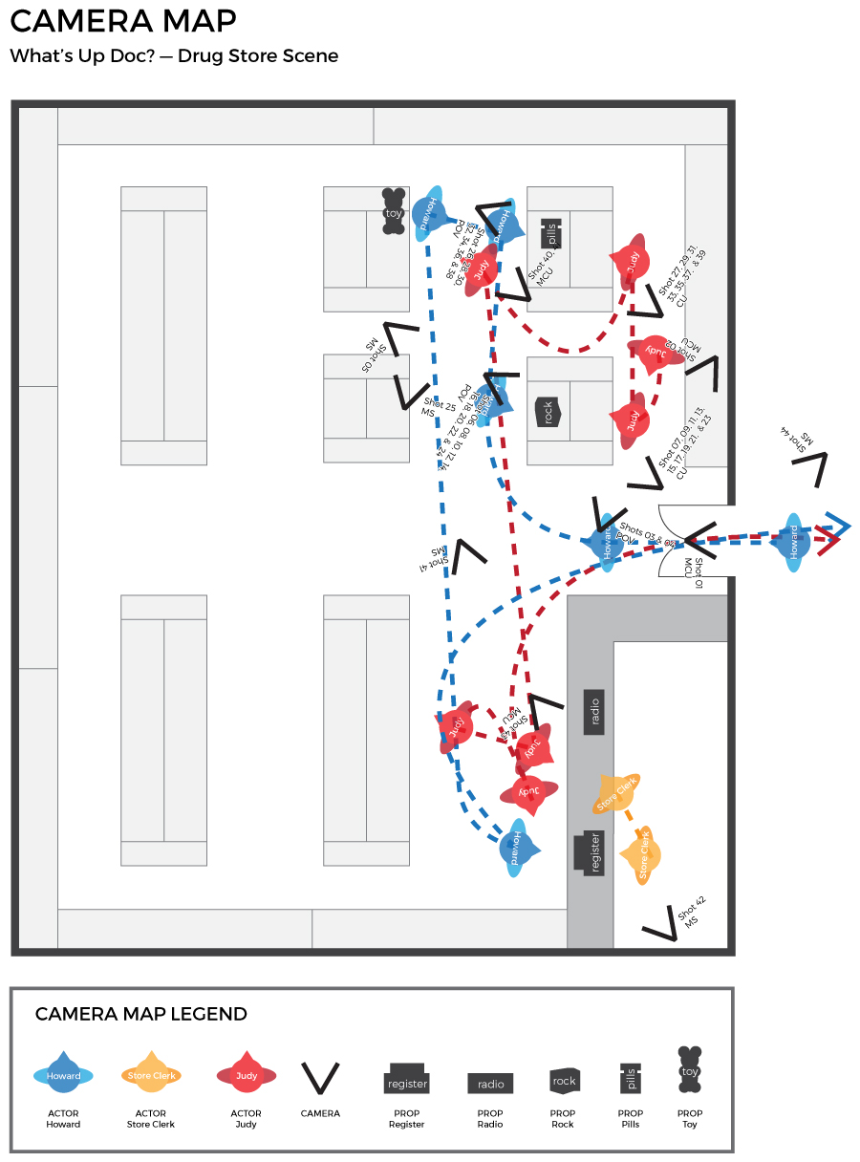

Works Cited

*What's Up, Doc*? Dir. Peter Bogdanovich. Prod. Peter Bogdanovich. By Buck Henry, David Newman, and Robert Benton. Perf. Barbra Streisand, Ryan O'Neal, and Madeline Kahn. Warner Bros., Inc., 1972.

Canby, Vincent. "Movie Review: What’s Up Doc?" *Movies*. N.p., 10 Mar. 1972. Web. 2 Oct. 2016. <http://www.nytimes.com/movie/review?res=EE05E7DF173DE774BC4852DFB5668389669EDE>.

Huntley, KE Monahan. "MenuDramatica®The Next Chapter in Story Development." *What’s Up Doc?* N.p., n.d. Web. 02 Oct. 2016. <http://dramatica.com/articles/whats-up-doc>.

TV Tropes. "What's Up, Doc? (Film) - TV Tropes." *TV Tropes*. N.p., n.d. Web. 02 Oct. 2016. <http://tvtropes.org/pmwiki/pmwiki.php/Film/WhatsUpDoc>.